The Great Southeast Pollinator Census August 23rd & 24th 2024

Insect Counting & Identification Guide

Thank you for being part of pollinator conservation by helping us document our pollinator populations! Here are your counting instructions.

Counting instructions:

- Choose a favorite pollinator plant for counting. This can be any blooming plant that shows insect activity.

- Count and categorize the insects that land on your plant. Count an insect each time it lands on your plant. Count for 15 minutes. The insect categories are:
  - Bumble Bees
  - Honey Bees
  - Small Bees
  - Carpenter Bees
  - Wasps
  - Flies
  - Butterflies/Moths
  - Other insects

- There is an insect counting sheet at the end of this booklet to make counting easier for you.

- Upload your counts on the website (https://GSePC.org). The portal to upload counts will open on the first day of the counts. We do not have the ability to accept mailed paper forms.)

- Post photos of your counters having fun, photos of your gardens, or anything you think would be of interest to the group on the Southeast Pollinator Census Facebook page

- Becky Griffin is the project coordinator and is available through email at beckygri@uga.edu if you have any questions.

- Counting hint: Your cell phone camera makes a great magnifier.

- The next pages are examples of the insects that you may see. Use these as your guides.

Have questions about counting?

Contact Becky Griffin at beckygri@uga.edu.
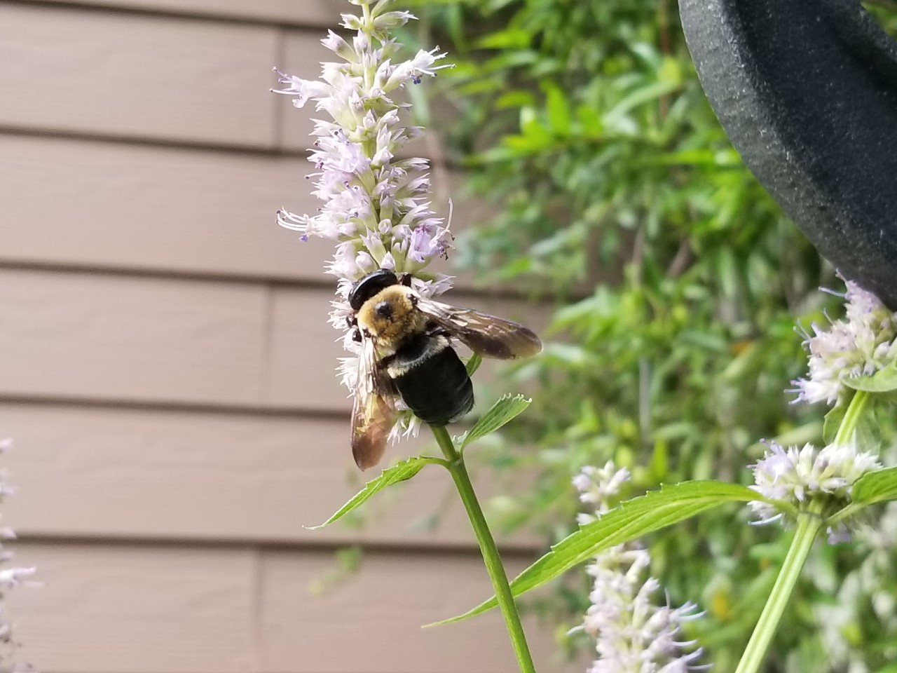
Carpenter Bees
(16 – 22 mm)
- Black body with yellow and black bands
- Dense hair on head and thorax
- NO HAIR on abdomen
- Broad head, thick body
- Males have yellow to white coloring on face, females all black on face

Carpenter Bee

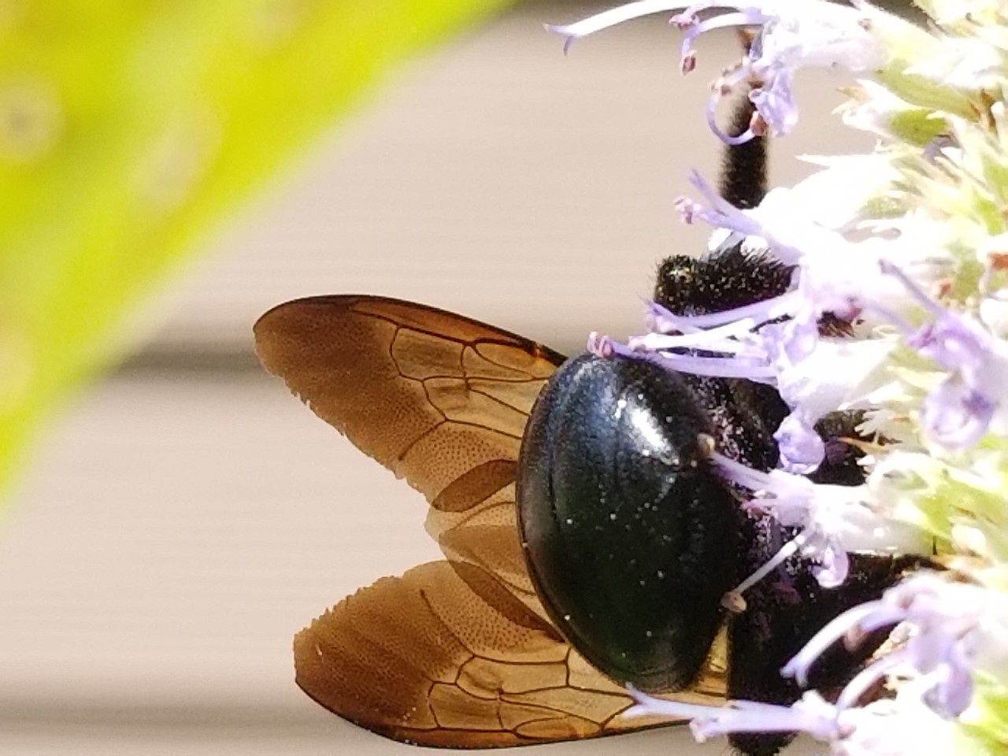
Carpenter Bee – Hairless Abdomen
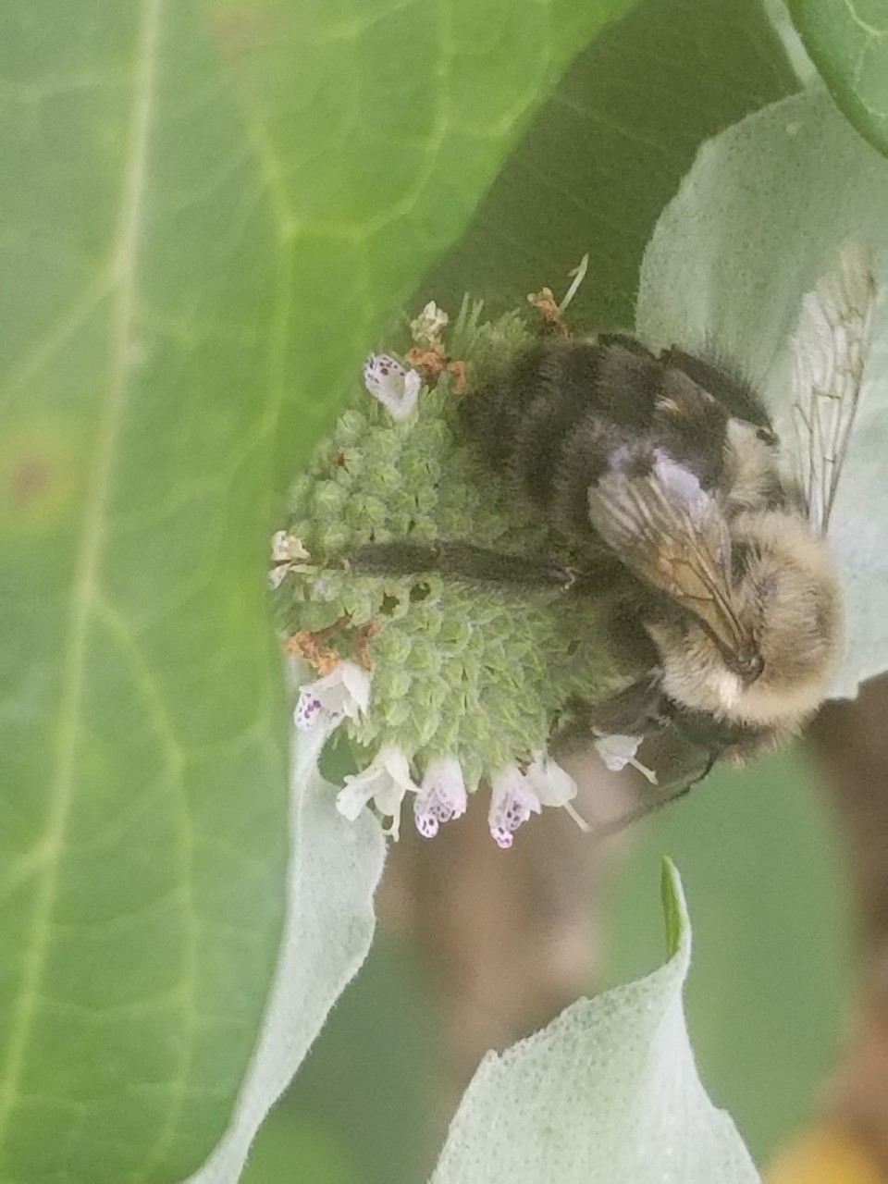
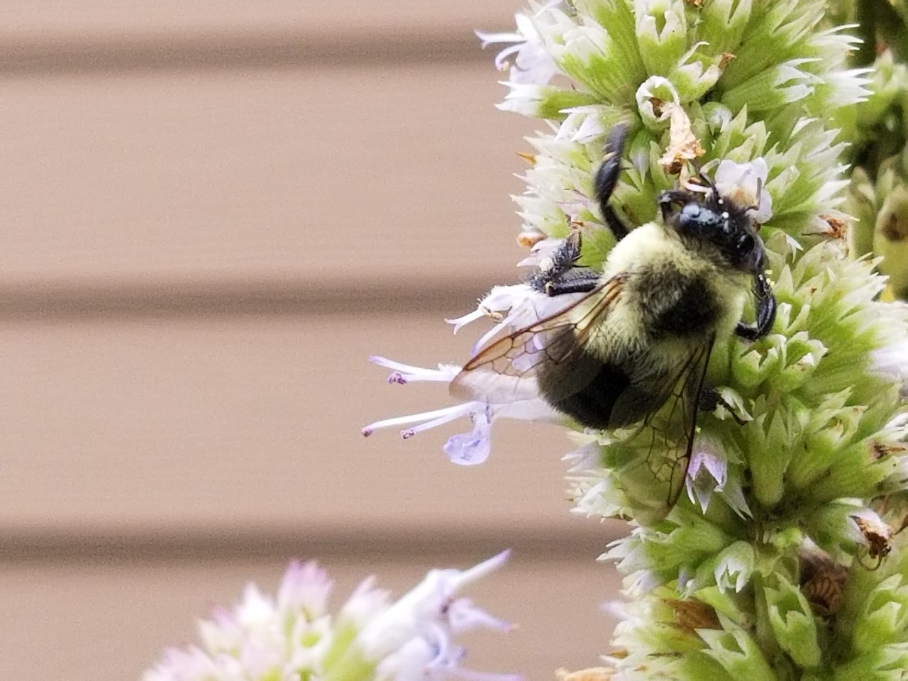
Bumble Bees
(10 – 19 mm)
- Black body covered with dense yellow and black hair
- Fat bee with small head
- Large thorax and abdomen
- Hairy abdomen
Bumble Bee

Bumble Bee – Hairy Abdomen

This photo illustrates the differences between the carpenter bee and a bumble bee. The carpenter bee is a “mack truck” while the bumble bee is more of a “pickup truck.”

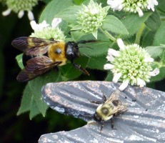

Carpenter Bee with a Bumble Bee
Photo credit: Bodie Pennisi, UGA Extension

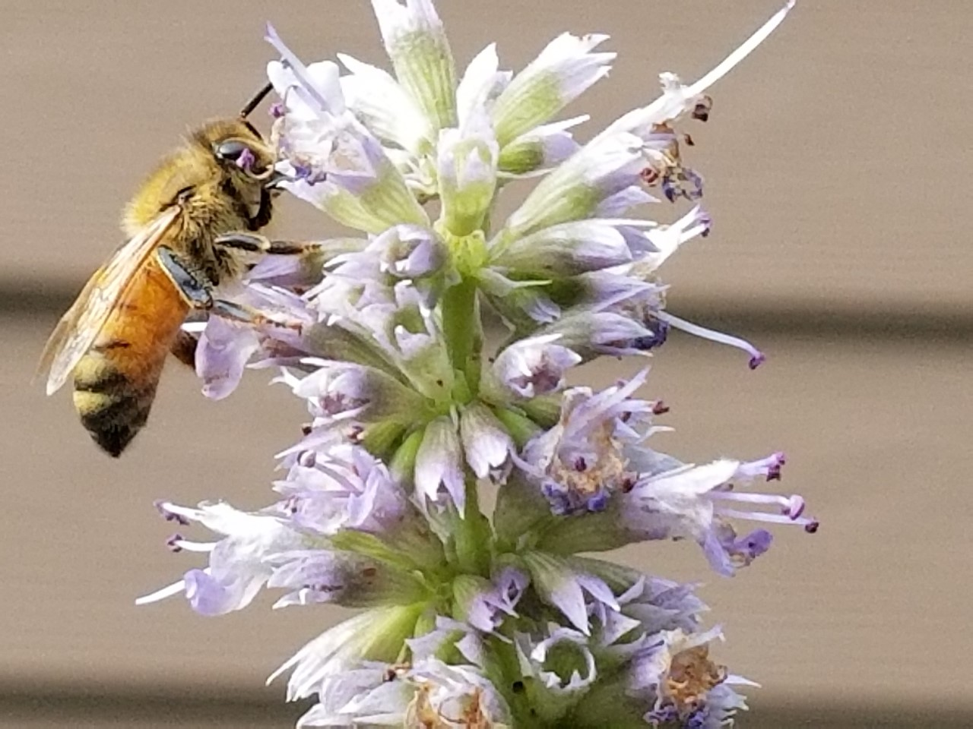
Honey Bees
(12 – 15 mm)
- Brown or black stripes on body
- Golden-brown hair covers abdomen

Honey Bee

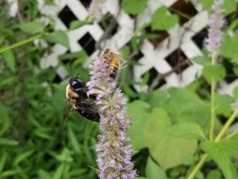
This photo shows a honey bee and a bumble bee together. The two are easily distinguishable.

Bumble Bee and Honey Bee

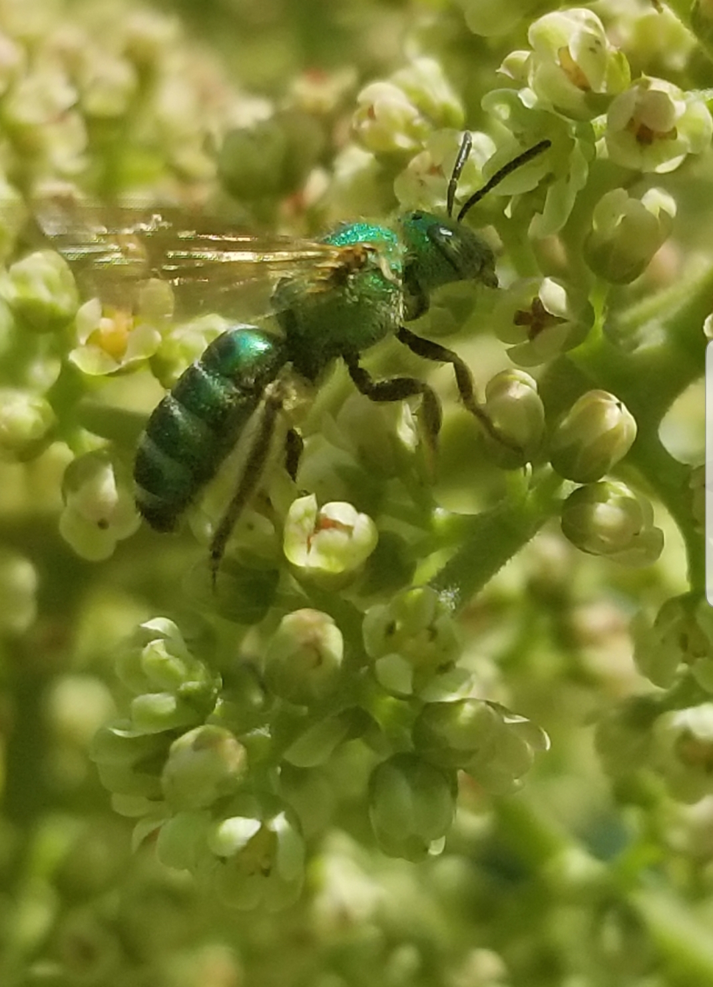
Small Bees
(Any bee smaller than a honey bee)
Can include:
- Leafcutter Bees
- Sweat Bees
- And others
- Note: Keep a lookout for the metallic shine of the sweat bees from the family Halictidae. Even though these bees can be small, the metallic color is easy to spot when the sun is shining on them.
Metallic green bee
Notice the dark striped abdomen of the leafcutter bee below. Remember if you can get a glimpse of the underside of the abdomen, the bee will carry the pollen there on the hairy scopa.
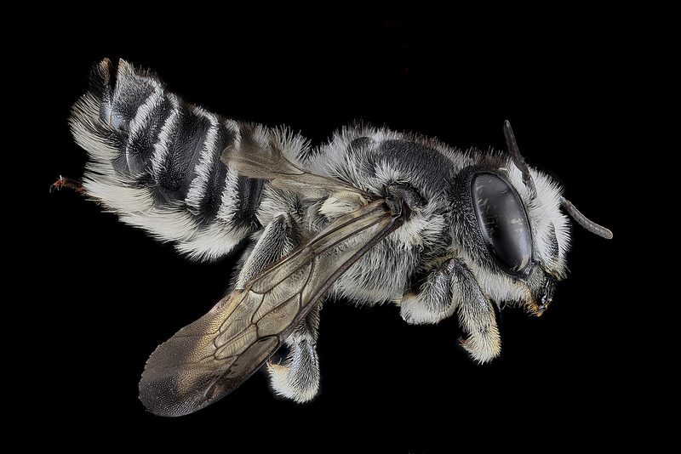
Photo credit: Bees of Georgia

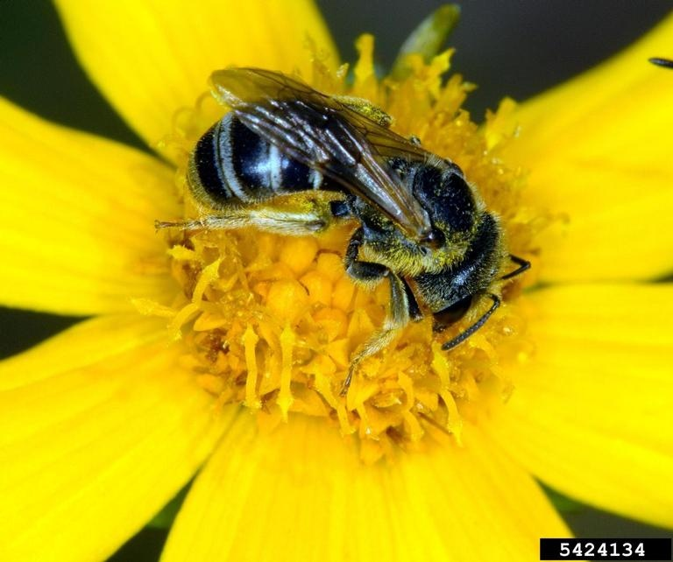
Leafcutter bee
Photo credit: David Cappaert, bugwood.org

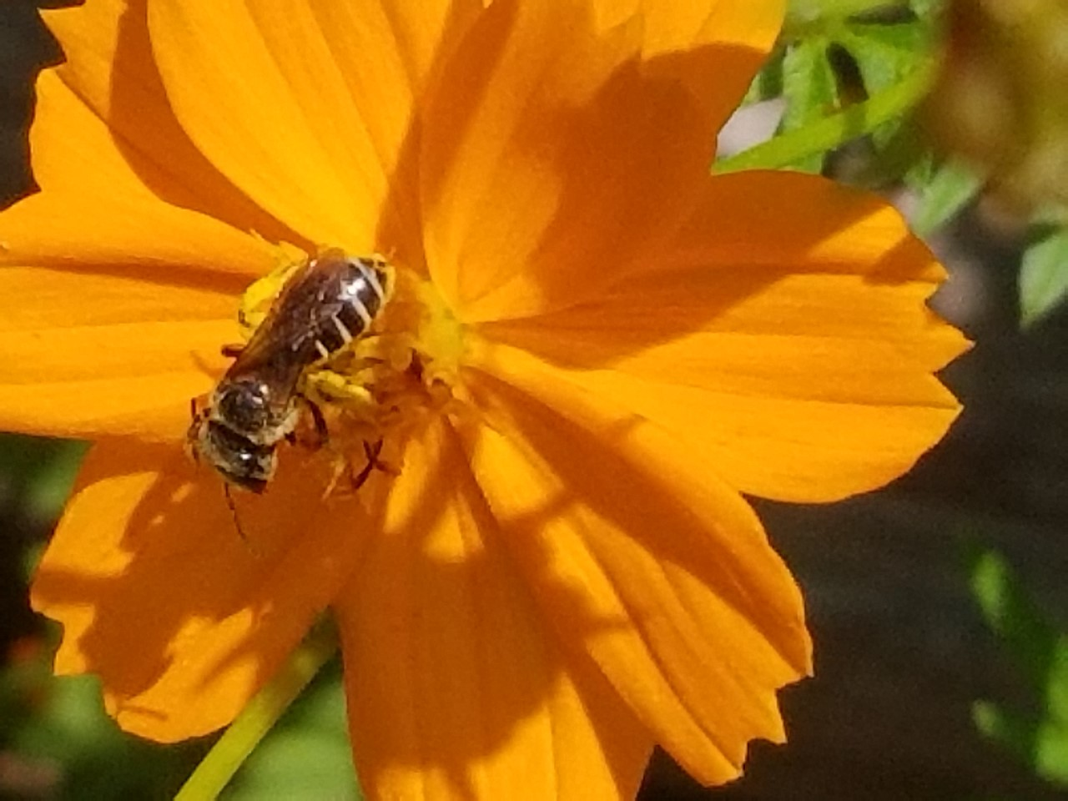
Small bee on cosmos flower
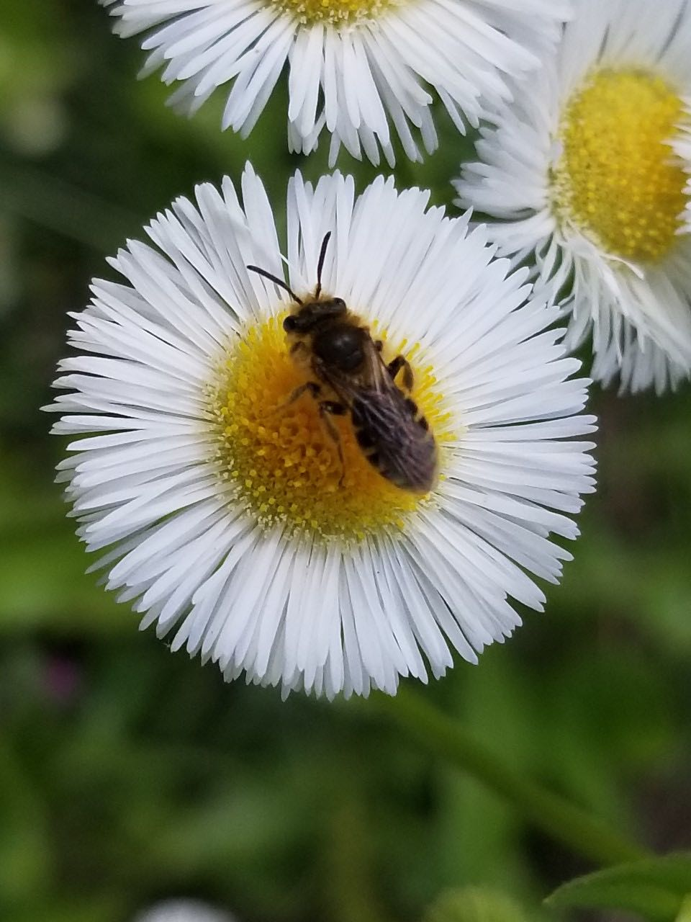

Small bee on aster
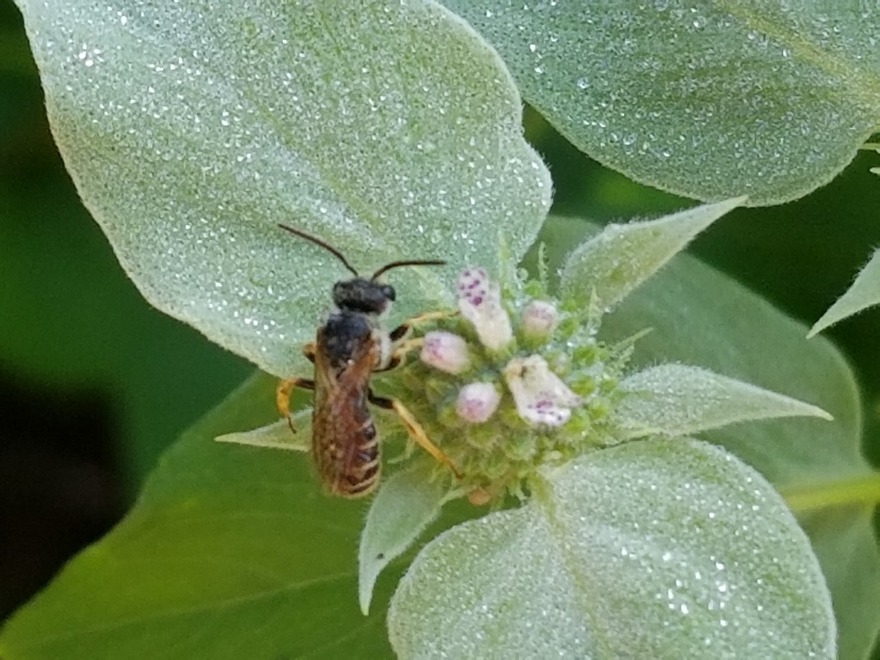

Small bee on mountain mint
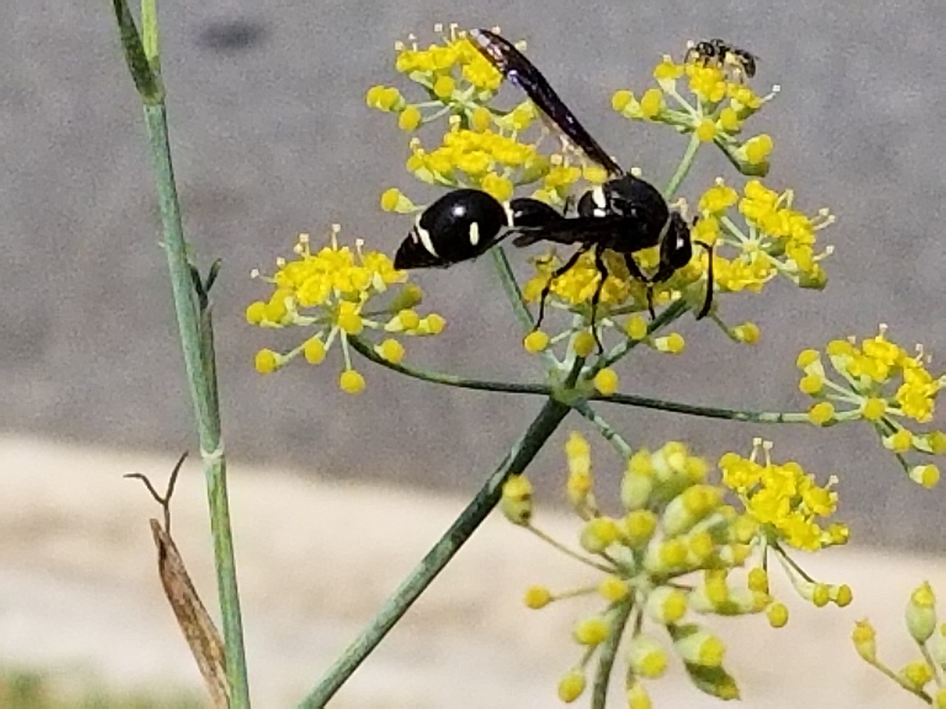
Wasps
(13 - 25 mm)
Can include:
- Potter Wasps
- Paper Wasps
- And others

These are generally hairless.
Many have very thin waists.
No pollen gathering hairs.
Long thin legs, often with spines.

Potter Wasp

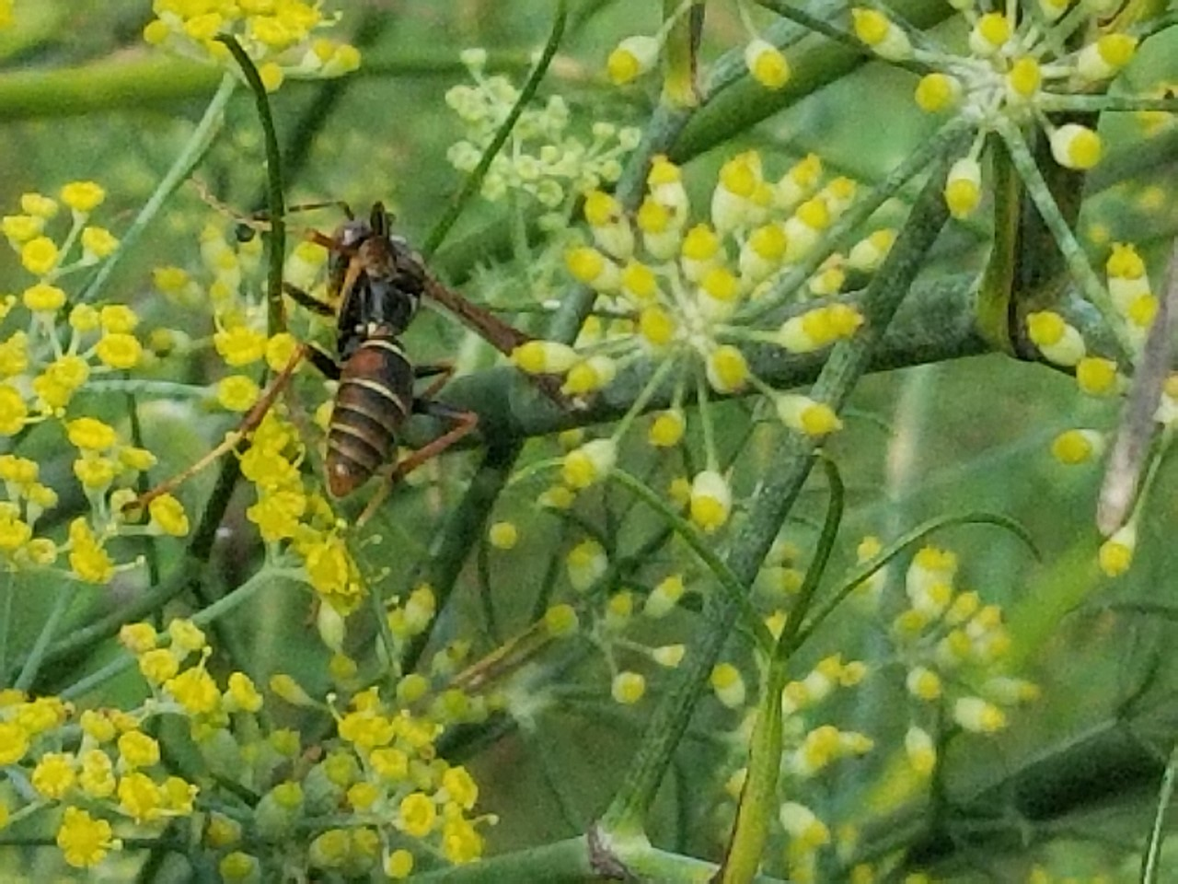
Paper Wasp

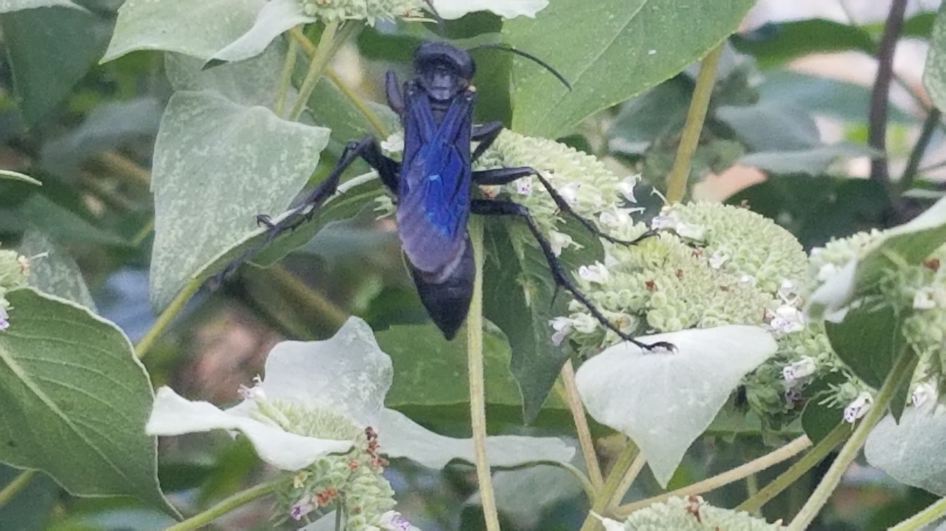
Great Black Wasp

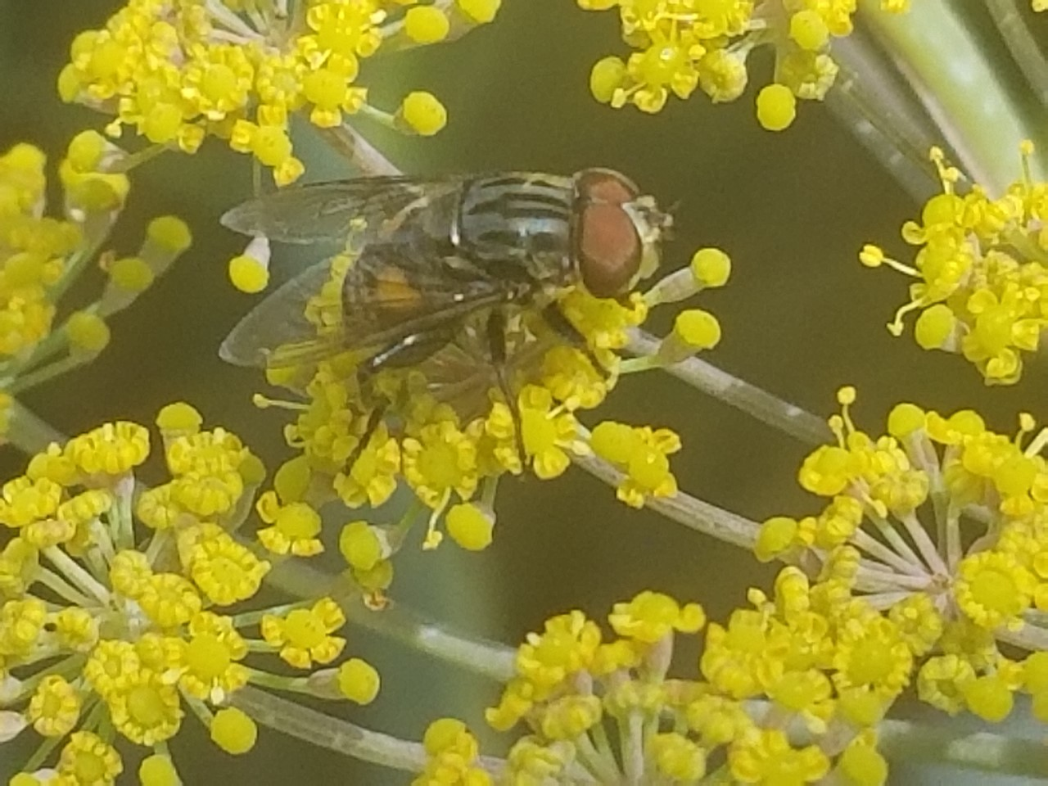
Flies
(6 – 13 mm)
- Have two wings instead of the four wings on bees and wasps
- Eyes are large and take up most of the face
- Small antenna

Note: Some flies are bee mimics. They have bee-like coloring and will visit flowers. The large eyes and small antenna will confirm you see a fly.
Fly (notice location of eyes and lack of large antenna)

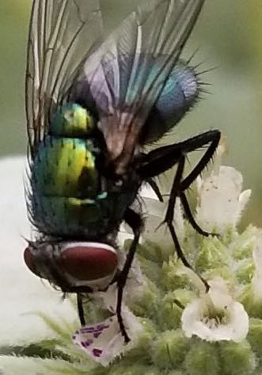
Tachinid Fly
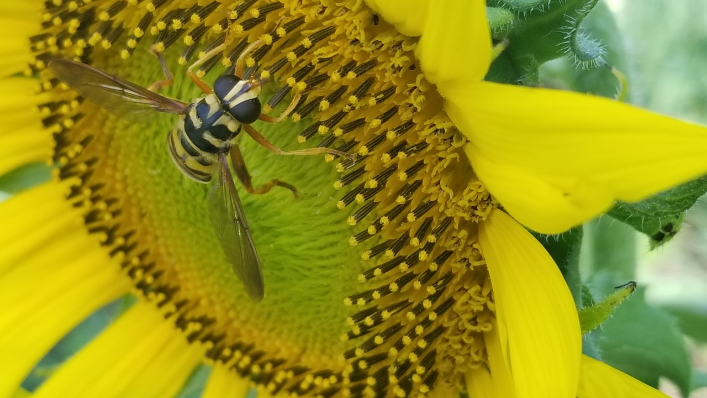
Flower Fly (Bee mimic)

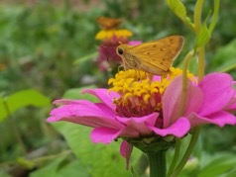
Butterflies and Moths
Can include:
- Skippers
- Gulf Fritillaries
- Monarchs
- Swallowtails
- Common Spring Moth
- And others

Skipper Butterfly
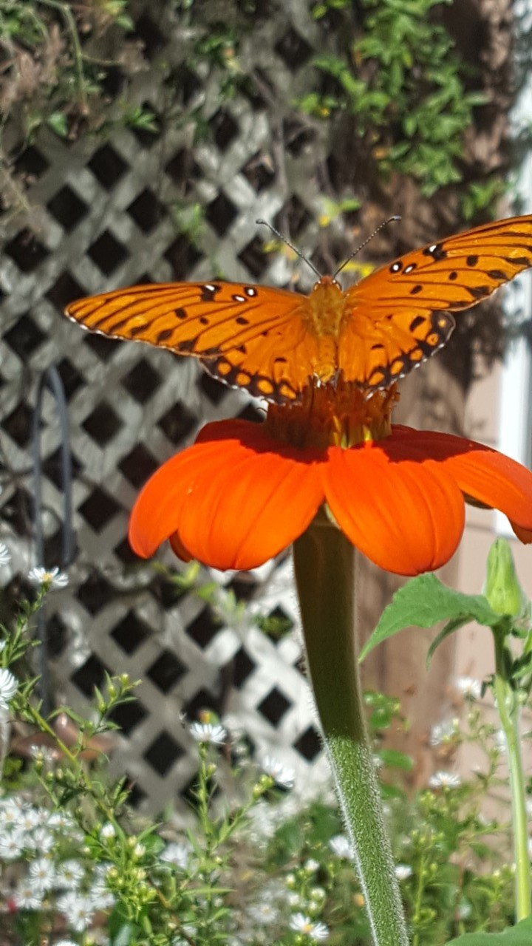

Gulf Fritillary Butterfly

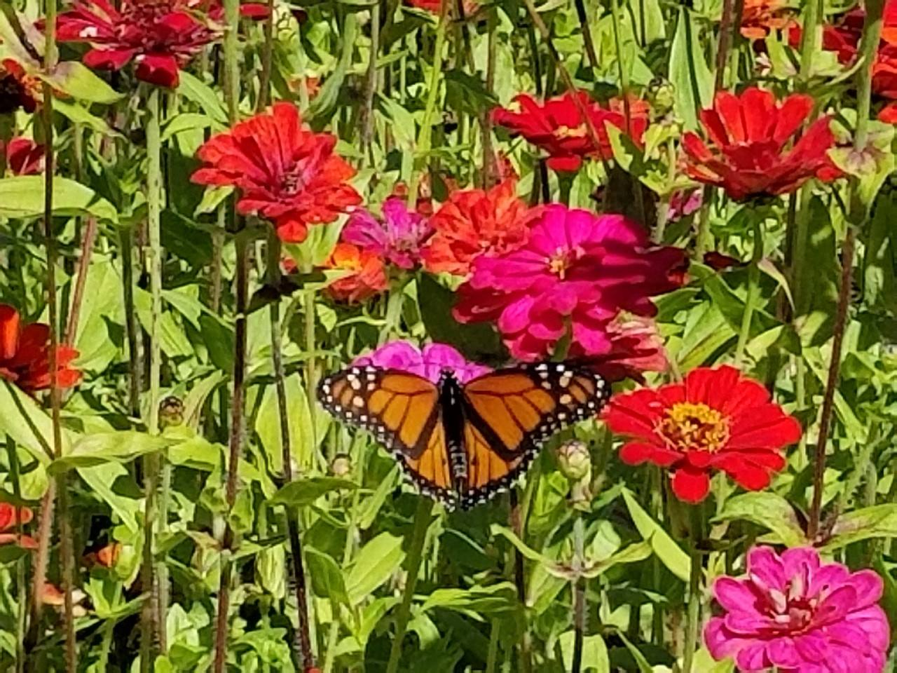

Monarch Butterfly

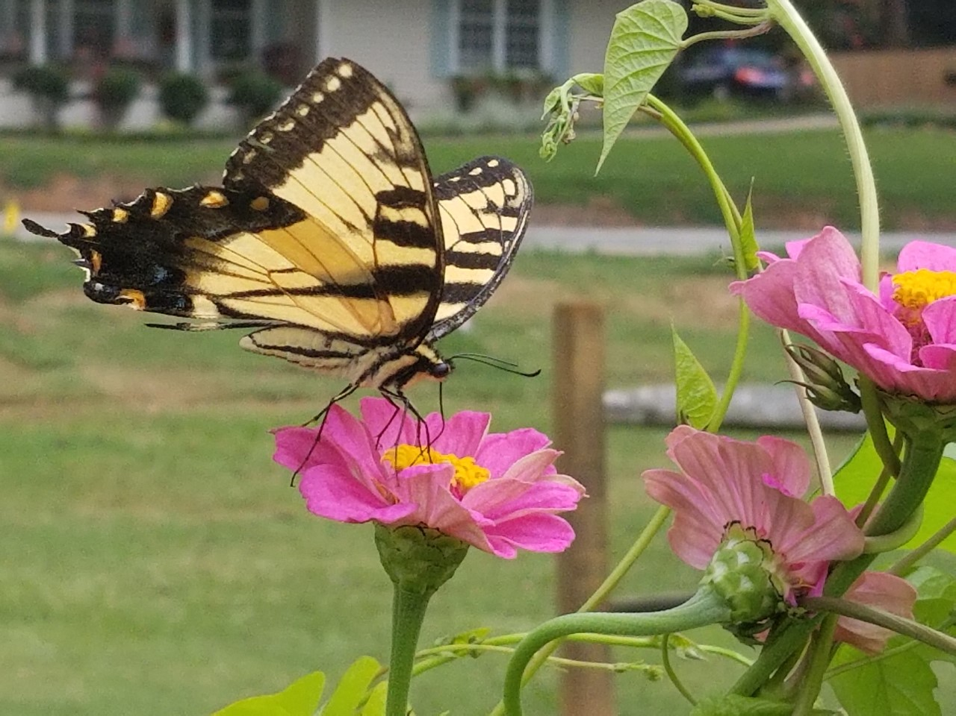

Eastern Tiger Swallowtail Butterfly

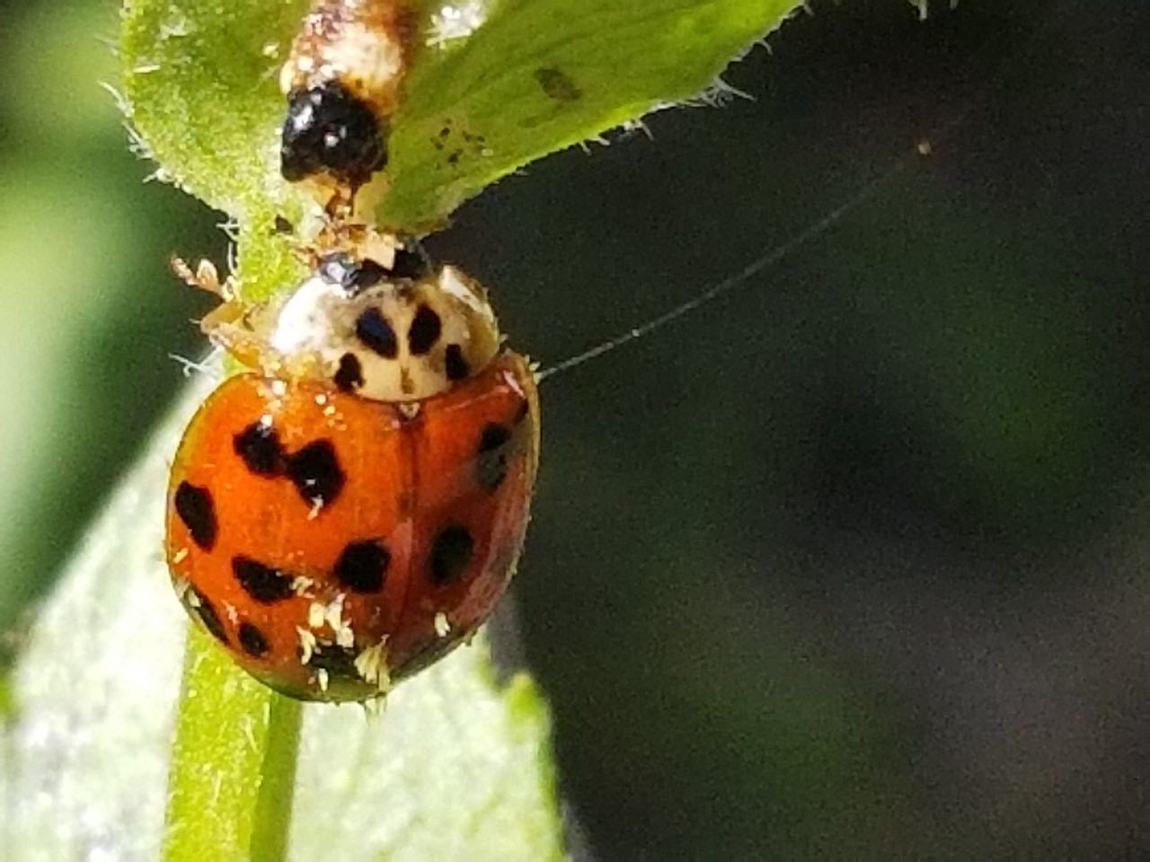
Other Insects
Can include:
- Beetles
- Dragonflies
- Lacewings
- And others
Lady Beetle

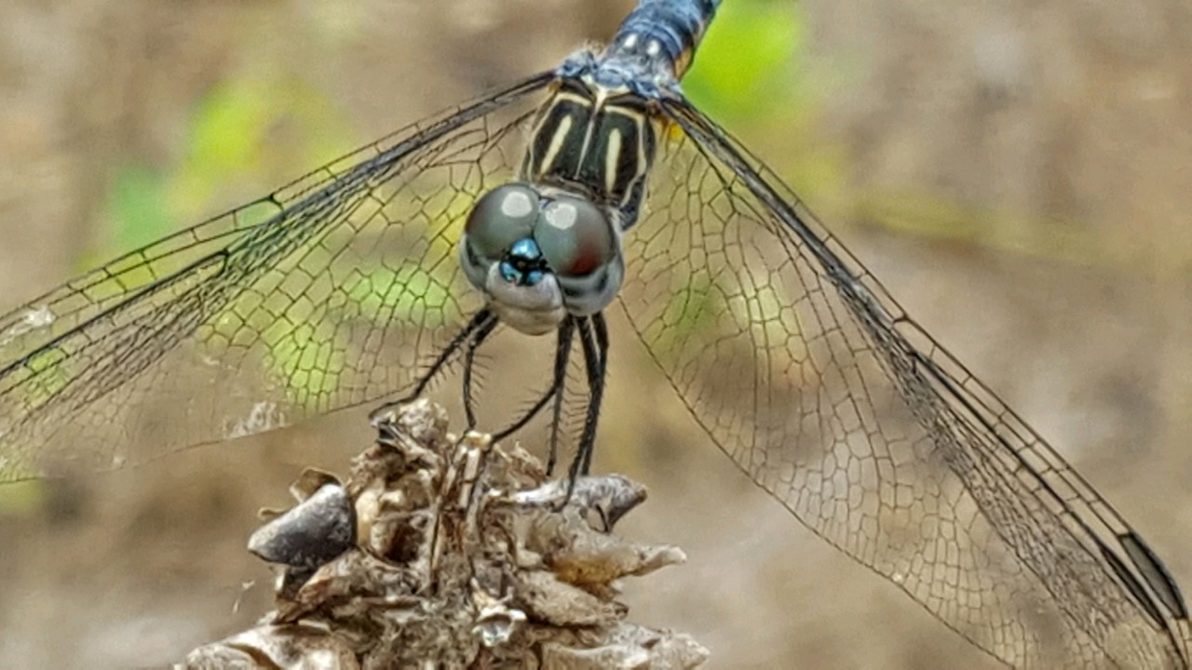
Dragonfly
Photo credit: Millard Griffin

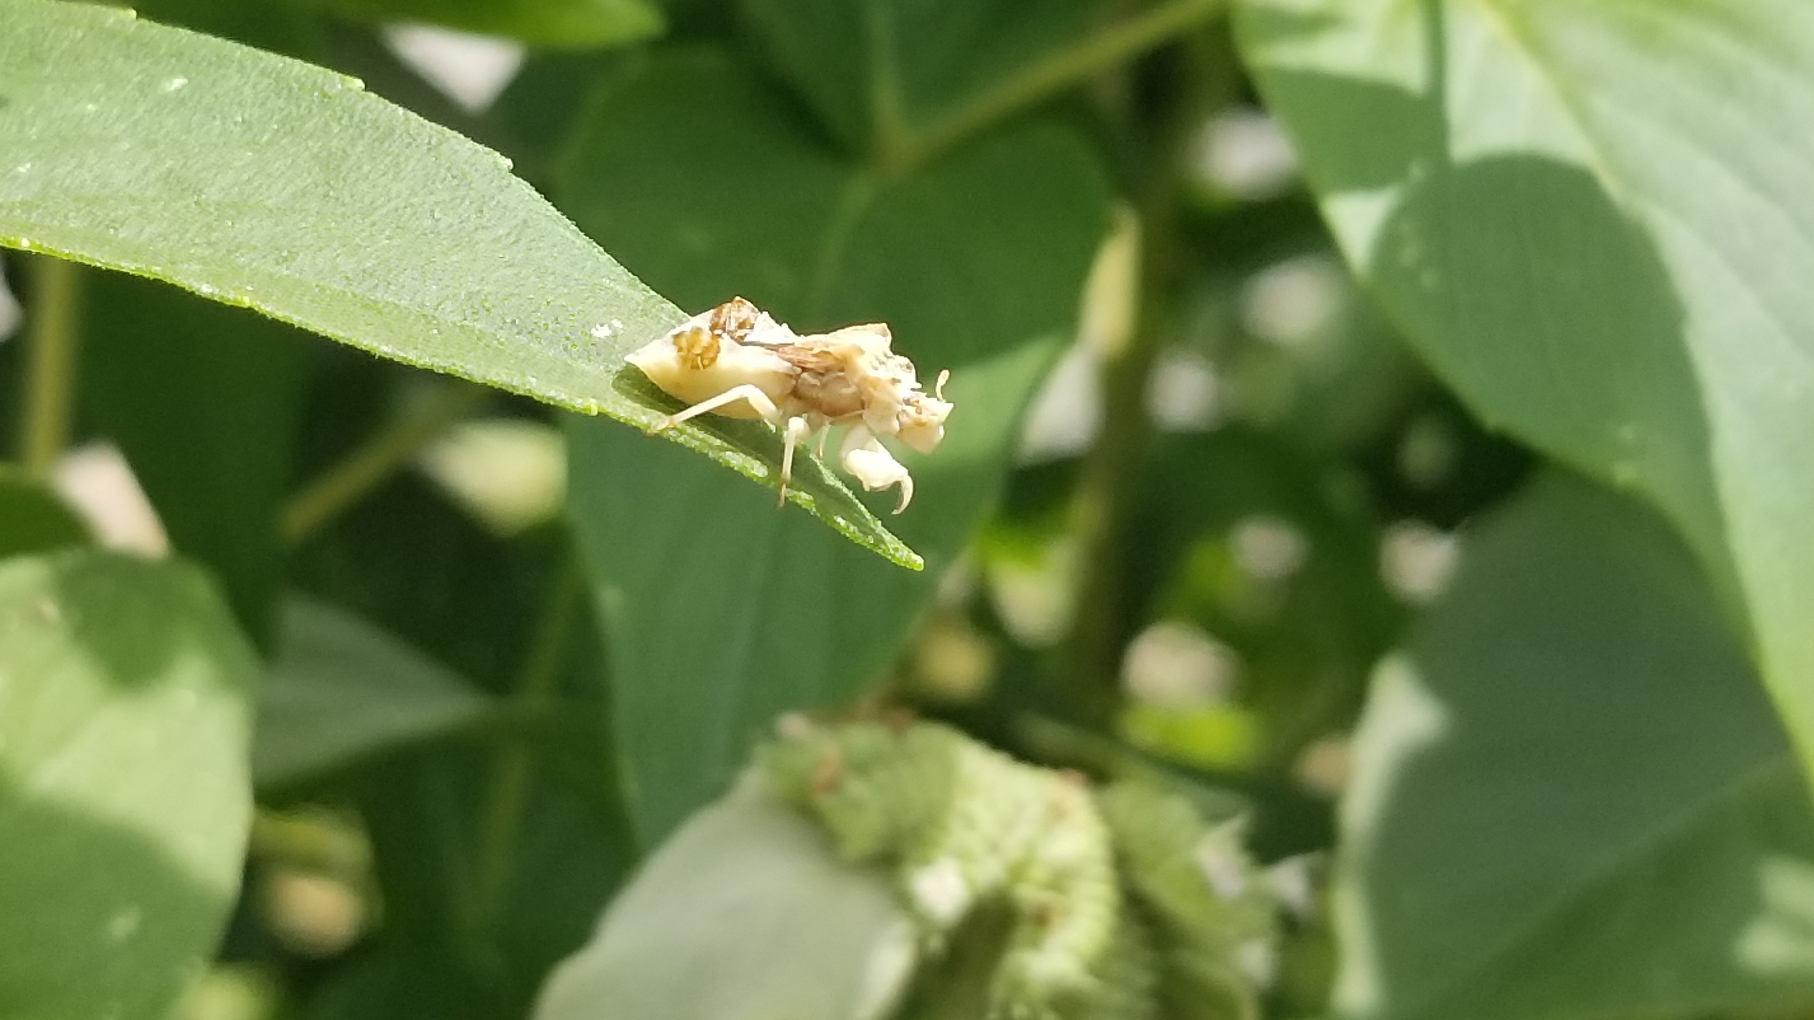

Ambush bug

Great Southeast Pollinator Census Observation Sheet

Name of participant: ____________________ Email: _______________________

Address of Garden (for mapping): ___________________________ County_______________

Would you consider your garden small (< ¼ of an acre) medium (>1/4 of an acre but < 1 acre) or large (>1 acre)

Date:

Time of count start: _________

Temperature: ____ °F

Weather conditions: Sunny Partly Cloudy Cloudy Rainy

Is there a honey beekeeper within 5 miles of your garden? Yes No Don’t Know

Name of pollinator plant used for counting. Please give common name and Latin name if you have it: _____________________

Counting Data:
Type of Insect | Number of times the insect lands on your plant
Carpenter Bees
Bumble Bees
Honey Bees
Small Bees
Wasps
Flies
Butterflies/Moths
Other Insects

Visit https://GSePC.org to upload your counts to the website. Every count is important so THANK YOU!

You can also use this QR code to get to the website for count uploads!
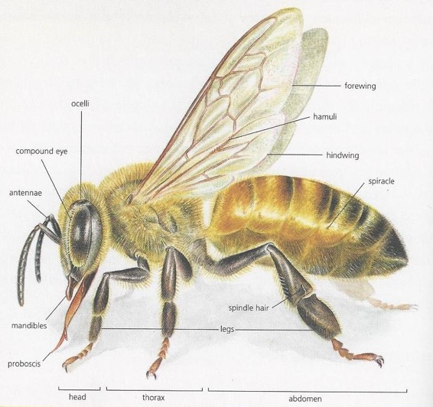

This program is coordinated by University of Georgia Extension. South Carolina participation is coordinated by Clemson University Extension and North Carolina participation is coordinated by North Carolina A&T State University. Florida participation is coordinated by University of Florida Extension/Marian County.

