You can upload counts here (or go to the website on your computer http://GSePC.org)

Name of Plant: ___________________________________ Date: _____________ Time: ____________

Weather Conditions: Sunny Partly Cloudy Cloudy Rainy Temperature: _________

Name(s): ___________________________________________________________________________________

 | Description of Insect | Number of Insect Landings on Your Plant
Carpenter Bee  (16-22mm) | Shiney Hiney 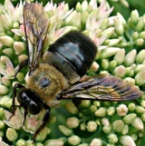 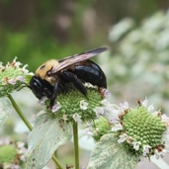
Bumble Bee  (10-19mm) | Fuzzy Rear 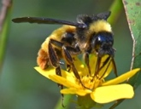 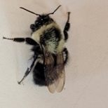
Honey Bee  (12-15mm) | 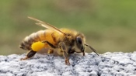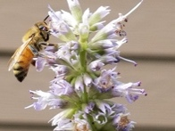
Small Bees (smaller than a honey bee) | 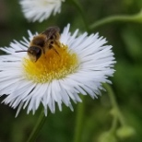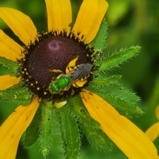
Wasps  (13-25mm) | Some have a skinny waist 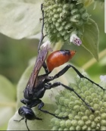 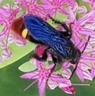
Flies  (6-13mm) | Antennae very short. Eyes take up most of their head.  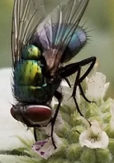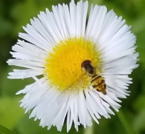
Butterflies & Moths | Don’t overthink it 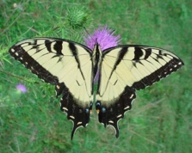 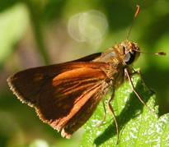
Other insects | 