You can upload counts here (or go to the website on your computer http://GSePC.org!)

Name of Plant: ___________________________________ Date: _____________ Time: ____________

Weather Conditions: Sunny Partly Cloudy Cloudy Rainy Temperature: _________

Name(s): ___________________________________________________________________________________

 | Description of Insect | Number Counted
Carpenter Bee  (16-22mm) | Shiney Hiney 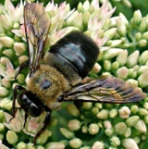 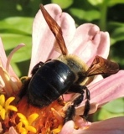
Bumble Bee  (10-19mm) | Fuzzy Rear 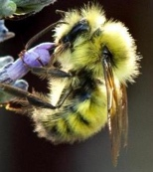 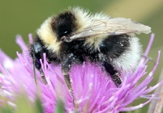
Honey Bee  (12-15mm) | 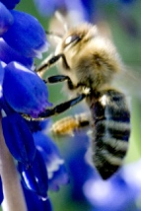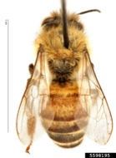
Small Bees (smaller than a honey bee) | 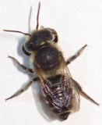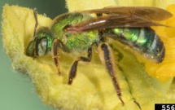
Wasps  (13-25mm) | Have a skinny waistline 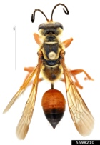 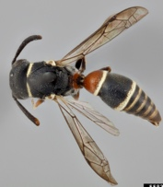
Flies  (6-13mm) | Antennae very small. Eyes take up most of their head.  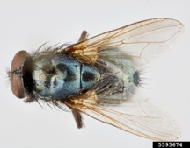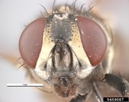
Butterflies & Moths | Don’t overthink it 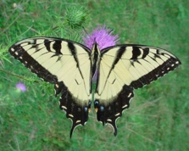 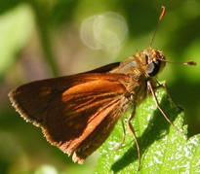
Other insects | 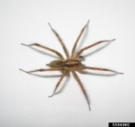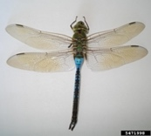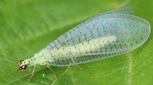
Photo credits on reverse.

Notes:

Thank you to all the photographers listed below who generously shared their beautiful photographs with us.

Image Number | Citaton
5459067 | Pest and Diseases Image Library, Bugwood.org / house fly
5471998 & 5594980 & 5497735 | Mohammed El Damir, Bugwood.org / emperor dragonfly, funnel web spider, leafcutter bee
5489208 | Whitney Cranshaw, Colorado State University, Bugwood.org / bumblebee
5490096 | David Cappaert, Bugwood.org / bumble bee
5551980 | Royal Tyler, Pro Pest and Lawn Store, Bugwood.org / carpenter bee
5568360 | B. Merle Shepard, Clemson University, Bugwood.org / sweat bee
5574566 | Ansel Oommen, Bugwood.org / carpenter bee
5582214 | Mary C Legg, Mary C Legg, Bugwood.org / honey bee
5583882 & 5593674 | Paul Langlois, USDA APHIS ITP, Bugwood.org / potter wasp, house fly
5598195 & 5598210 | Hanna Royals, USDA APHIS PPQ ITP, Bugwood.org / honey bee, golden digger wasp
9009012 | Lisa Anness, LDA Associates, Bugwood.org / baracoa skipper
9009075 | Herbert A. 'Joe' Pase III, Texas A&M Forest Service, Bugwood.org / tiger swallowtail

